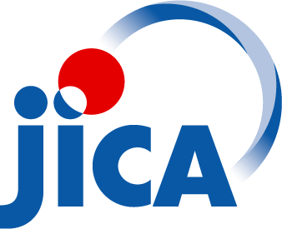
Application Form.

Name of Workshop:
Safety in the Field Workshop
Hua Hin, Thailand
9-15 June 2019

Deadline for submitting Application: 23 April 2019

Applicant’s Information

First Name (s) ______________________________ Last Name ____________________________

Nationality ________________________________ Male Female Index No._______

(UN Staff Member only)
Date of Birth _______________________________ Passport Number ______________________

Organisation Name _________________________ GOV NGO UN

Job Title _______________________________________________________________________

Office Address ______________________________________________________________________________

Country __________________________________ Email address _________________________

Office phone ( ) ________________________ Fax Number __________________________

Description of mission of your organization/department/section you are working:

_____________________________________________________________________________

_____________________________________________________________________________

_____________________________________________________________________________

_____________________________________________________________________________

_____________________________________________________________________________

_____________________________________________________________________________

_____________________________________________________________________________

Emergency Contact

Name of Contact person _________________________ Phone number ( ) ______________

Applicant’s Detailed Information

Your current duty station ____________________________________________________________

Region/countries/areas for which you are covering/responsible for (if applicable) _________________________________________

1. Your current job responsibilities:

2. Other experience in the humanitarian or emergency context:

3. Countries worked in and for how long:

4. Education:

5. In the past, if you have ever attended UNHCR-eCentre emergency or security related event (workshop, training, symposium, etc.) Please list them here:

6. Other relevant skills, experience or training:

7. Brief description of security environment in your current area of operation:

8. Please identify your main objectives for participating in the event:

9. Other relevant interests or comments.

Signature: _________________________________ Date:________________________________

Please send you application to email address kosaka@unhcr.org indicating in subject line “Application SIF 2019", copying ecentre@unhcr.org, before the deadline.

